BARANGAY MANAGEMENT INFORMATION SYSTEM

FOR THE MUNICIPALITY OF MAYANTOC

JOHN CARLO F. ASUNCION

JOHN REY M. BOLOS

JERENEL C. LACAULAN

BRYAN C. MALLARI

Republic of the Philippines

TARLAC AGRICULTURAL UNIVERSITY

Camiling, Tarlac

March 2023

# APPROVAL SHEET

Insert here the ISO Approved Form for Undergraduate Thesis. Download from this link >> (<https://docs.google.com/document/d/13mnrO5AUU-3aVMtAv3QmeD5uI2PVhihB/edit?usp=sharing&ouid=114013549150064370299&rtpof=true&sd=true>).

# BIOGRAPHICAL SKETCH

On September 25, 2000, John Carlo Felizardo Asuncion was born at Barangay San Jose, Mayantoc, Tarlac. He is the oldest son among the three children of Juvy Siatrez Asuncion and Ofelia Agbayani Felizardo.

He spent his elementary education at San Jose Elementary School and finished on 2012. He continued his secondary education at the Mayantoc High School and finished at the year of 2017. But after spending his junior high school life at Mayantoc High School, he continued his senior high school at Glory Dei Montessori College and graduated on 2019. He took Bachelor of Science in Information and Technology for his dream to be an Information Technology Officer working under the office of Philippine National Police.

John Carlo F. Asuncion

Researcher

# BIOGRAPHICAL SKETCH

John Rey M. Bolos is currently a fourth year Information Technology (IT) student at the Tarlac Agricultural University. He was born in Santa Ignacia, Tarlac, on September 09, 2000.

He is the youngest among the siblings of Mr. Mateo C. Bolos and Mrs. Cely M. Bolos. In March 2006, he completed his kinder garden years at Población West Day Care Center at Santa Ignacia, Tarlac. Then he took his elementary years at Santa. Ignacia North Central Elementary School and finished in 2013. He pursued his high school years at Santa Ignacia Highschool in 2013 and ended with honor, and in year 2017, he took his senior high school years at the same school and finished with honor as well. He took Bachelor of Science in Information and Technology for his plan to work under government as an Information and Technology Professional.

John Rey M. Bolos

Researcher

# BIOGRAPHICAL SKETCH

Jerenel C. Lacaulan is a fourth-year Information Technology (IT) student at the Tarlac Agricultural University. He was born in New Salem, Gerona, Tarlac, on December 14, 2000.

He is the youngest among the siblings of Mr. Jeremias N. Lacaulan and Mrs. Lorna C. Lacaulan. In March 2006, he completed his kinder garden years at Quezon Elementary School. Then he took his elementary years at Quezon Elementary School and finished in March 2013. He pursued his high school years at Quezon National High School and finished in the year 2017, and he took his senior high school years at the same school and ended with honors. He took Bachelor of Science in Information and Technology due to his intention to work for an IT related company.

Jerenel C. Lacaulan

Researcher

# BIOGRAPHICAL SKETCH

Bryan C. Mallari is a fourth-year Information Technology (IT) student at Tarlac Agricultural University. He was born in Calayaan Gerona, Tarlac on April 14, 2001.

He is the oldest among the siblings of Mr. Rudy T. Mallari and Mrs. Marissa C. Mallari. In March 2007, he completed his Day Care at Parsolingan Day Care Center. Then he took his grade 1 at Parsolingan Elementary School, continued the rest of his elementary years at Santa Ignacia South Central Elementary School, and graduated in 2013. He pursued his high school at Padapada National High School in 2013 and finished in 2017; he took his senior high school at the same school and completed it as a conduct awardee. He took Bachelor of Science in Information and Technology for his plan to be a Full Stack Web Developer.

Bryan C. Mallari

Researcher

# ACKNOWLEDGMENT

The researchers acknowledge and thank their adviser, Ms. Maria Regina M. Pablo. Thank their professor Dr. Sheila R. Lingaya and the panel members, Mr. Renel F. Dumlao, and Mr. Bryan Paul D. Danganan. Their guidance and advice carried the researchers through the hardship of writing their paper and developing their system. They also want to thank the other professors, who gave their comments and suggestions to improve the system and become more reliable.

They want also to give their special thanks to their parents, who watch, appreciate, and encourage them to pursue the achievements they are achieving right now. Their enthusiastic support and continuous prayer gave them the courage to finish their capstone project.

In addition, they want to thank the staff and residents of Barangay San Jose, Mayantoc, Tarlac for participating in the data gathering and evaluation. With all of you, we cannot finish this study. They would be also thanking their friends who tap their backs when they almost give up on finishing their capstone study.

Lastly, they would like to thank God for the continuous blessings that he gives us. He answered their prayers on completing this study. He supports and guides them in their difficulties and let’s pass through them. They will always trust you for their future.

# ABSTRACT

The study was to develop a web-based Management Information System for the Municipality of Mayantoc that serves as a helping tool to the barangay and offers a better service for residents to address their concerns immediately. The system is designed to generate accurate and reliable documents. In addition, the Barangay Management Information System helps the residents in requesting a barangay documents and reporting incidents.Update the Table of Contents by clicking a space in the Table of Contents then Update Table without highlighting the texts. You may also right-click anywhere in the TOC, then choose Update Field then Update Entire Table.

The study hastens the requesting of records and reporting of incidents. The system's development process used the Water Fall Model phases, which include requirements, design, implementation, verification, and revision phases that enhance and build up the system. A total of 60 participants evaluated the system in terms of usability and functionality.

The Barangay Management Information System for the Municipality of Mayantoc has a substantial influence on future users, which is helpful to employees and citizens based on the system's accessibility and applicability to the barangay.

# TABLE OF CONTENTS

APPROVAL SHEET ii

BIOGRAPHICAL SKETCH iii

BIOGRAPHICAL SKETCH iv

BIOGRAPHICAL SKETCH v

BIOGRAPHICAL SKETCH vi

ACKNOWLEDGMENT vii

ABSTRACT ix

TABLE OF CONTENTS x

LIST OF TABLES xiii

LIST OF FIGURES xiv

LIST OF APPENDICES xv

INTRODUCTION 1

Background of the Study 1

Significance of the Study 2

Objectives of the Study 2

Scope and Delimitations 4

Definition of Terms 5

REVIEW OF RELATED LITERATURE AND STUDIES 6

Related Literature 6

Related Studies 7

METHODOLOGY 9

System Development Methodology 9

Data Gathering Procedures 10

System Design 11

Tools used in the Development 11

Evaluation /* If User Evaluation and/or Subject Expert Evaluation */ 12

Validation Testing /*If Model Testing/Software Testing as Method Evaluation */ 13

Data 13

Accuracy /* Add additional <Heading 3> for 14

RESULTS AND DISCUSSION 16

Name of the IT Solution 16

User Requirements 16

Hardware and Software Requirements 16

Evaluation /* or Validation */ Results 17

SUMMARY, CONCLUSION AND RECOMMENDATION 20

Summary 20

Conclusion 20

Recommendation 20

REFERENCES 21

APPENDICES 22

LIST OF TABLES

Table 1. From "References" > Insert Caption > Table. 6

Table 2. Table Title Should be end With a Period. 12

Table 3. Table Title Should be end With a Period. 13

Table 4. Evaluation of Users on Software Usability. 17

Table 5. Accuracy of the IT Solution. 18

LIST OF FIGURES

Figure 1. From "References" > Insert caption > Figure 9

Figure 2. Screenshot Showing Evaluated Feature 18

# LIST OF APPENDICES

Appendix A. User Interfaces

Appendix B. Sample Outputs or Reports Generated

Appendix C. Questionnaire

Appendix D. Evaluators (especially Subject Experts’) Profile

Appendix E. Grammarian’s Certificate

Appendix F. TAU DRD/CET ISO FORMS ACCOMPLISHED

# INTRODUCTION

## Background of the Study

Most barangays in the Philippines use computers for electronic tasks such as gathering residents' data, processing their files, documenting activities and crimes, presenting their achievements, and using spreadsheets for data recording. Using a system can increase productivity and provides better services to the barangay. The system helps the residents in efficiently addressing their issues. With the use of the system, they may have more time to discuss their concerns with the barangay officials online. The system can easily address request of documents and reports of incidents quickly.

The researchers developed a Management Information System which can assist the barangay authorities, particularly the secretary and chairman, to cope with their work efficiently. The system will provide a better method of data collection, more advanced data monitoring, well-secured data storage, and an easier way to gather the needed information. The system provides those workers an easy access to each resident’s information and give them the capability to create any required reports. Start with the area of the study. Use an inverted triangle approach to tell the research story from general overview and on to the specifics. Be generous in your citations because it adds credibility to your work. You should specifically cite statements of facts to support your arguments (i.e. Background).

The Barangay Management Information System only allows authorized officials and residents with authority to access the barangay information and records services. The users can access it online using their preferred device with a pre-installed browser, such as cellphones, tablets, laptops, and personal computers. Residents may easily get documents and file reports through the systems at any time. The researchers' goal is to make the barangay's services more accessible to everyone. The system would act as a connection between residents and barangay services.

## Significance of the Study

The study is very significant to the Sparkling Agro farm to easily fasten their work and secure the data from creating the reports of the pigs on the farm.

For the piggery owner and industry, this system could help them generate a report for their pigs to support their business.

This project will be a reference or guide for future IT students' studies using Information Technology at the Tarlac Agricultural University.

For researchers, this study could serve as reference material for future researchers on Information and Technology.

## Objectives of the Study

The main objective of the study was to develop a web-based Management Information System for the Municipality of Mayantoc:

Specifically, the study aims to achieve the following objectives:

1. to develop a Barangay Management Information System that consist of:

a.1 Registration module that will record the resisdent’s demographic profile;

a.2 Provide information about the barangay;

a.3 Module for resident’s request;

a.4 Module for reporting unusual events that happened;

1. to validate the proposed IT Solution through end user evaluation :

b.1 Usability

b.2 Functionality

## Scope and Delimitations

Barangay Management Information System will serve as a helping tool to the authorities and staff of barangays in the Municipality of Mayantoc which offered a reliable storage of data of individuals in the barangay.

The system only permitted the administrator to change another user’s password if they were blocked due to erroneous password input. The system does allow users to view their demographic profiles. Only the administrator will be able to review and verify requests and reports of residents.They are the boundaries that the researchers set in terms of duration, population size and type of evaluation respondents or participants, etc.

The suggested system focuses on existing system concerns such as Capacity, Backup, Monitoring, and Security to make system safer, robust, regularly backed up, and continually monitored to detect system flaws.

There are parameters that the researchers established in terms of time, population, size, and kind of assessment respondents or participants, among other things.

## Definition of Terms

**Accomplishment** The system successfully achieved the user's task in the system.

**Barangay** Is the Philippines’ lowest administrative division and a Filipino name for a village, district, or ward.

**Certificate** is a document that proves someone owns something.

**Clearance** is a document that grants someone the right to own something.

**Database** it is used to store or collect information.

**Demographic** it is the general characteristics of persons and populations, such as age, gender, and income. Are collected and analyzed.

**Flexibility** It shows how good the design of the system.

**Information** Data that has been sorted or categorized and has some relevant values to the recipient.

**Organization** It tells how well the arrangement of the data is in the system.

**Web-Based** can be access through pre-installed web browser.

# REVIEW OF RELATED LITERATURE AND STUDIES

## Related Literature

The Philippines is divided into local government units (LGUs) classed as provinces, cities, municipalities, and barangays, each with its own set of resources. Each staff uses a manual recording of each resident’s demographic profile. According to (Bondoc, 2019), in manual transactions, the quality of services declines as manual handling of transactions takes more time, is prone to human error, and is less secure in keeping records. On the other hand, designing and developing a barangay management system could help enhance the management of the different transactions. With the system, the generation of useful, up-to-date documents and reports and the ease of administration of varying barangay’s projects, programs, and activities will be possible (Bautista, 2015).

This barangay information management system will be possible with the help of the Database to store, retrieve, update, and delete data. According to (Susanto & Meiryani, 2019), the collection of the demographic profile of the residents is possible through the help of a Database Management System. Database Management System (database management system- DBMS) is software that makes it easy for organizations to centralize data, manage data efficiently, and provide access to application programs. DBMS acts as an interface between application programs and physical data files. When an application program calls a data file, such as gross salary, the DBMS searches this data in the Database and gives it to application program. DBMS relieves the task of the programmer or end-user to understand where and how the information is stored by separating logically and physically from the data. DBMS serves to reduce and eliminate data redundancy and maximize data consistency.

In the article (Saeed, 2017), the study is the solution to the problems stated to enhance the quality of service a barangay office offers to its clients. DBMS facilitates a better flow of information. Its application does the collection of data, processing of information, and controlling of information. It is needed for the function role, performance role, and support. The System ensures that the appropriate data is collected from various sources, processed, and sent to needy destinations.

The System is expected to fulfill the information needs of an individual/residents. The proposed study focuses on presenting possible solutions to the problems stated and enhancing the quality of service a barangay office offers to its clients or residents. Furthermore, the study serves as an awakening factor for all government offices, from highest to lowest levels, to align with the government’s view of globalization and competitiveness in today’s Information Age.

System quality is concerned with the System’s properties. Reliability, reaction, speed, system functioning, simplicity of use, and adaptability are characteristics. In contrast to system quality, information quality focuses on the AIS’s output properties. Some criteria associated with information are relevance, correctness, conciseness, completeness, usability, and timeliness (Nkanata, 2019). In the article of (Al-Okaily et al., 2020), as accounting information is the main output of AIS, it is easy to realize that these outputs should have prominent features of reliability, accuracy, and timeliness that influence performance.

A data description language processor (DDL processor) constructs the database, and a database manager distributes the database to users in all DBMSs. Data Manipulation and query languages are high-level software or software languages that resemble human language, allowing users to extract data and information from a database quickly. The database administrator, or DBA for short, is in charge of the Database and DBMS (Aken et al., 2017).

## Related Studies

The Philippines is divided into local government units (LGUs) classed as provinces, cities, municipalities, and barangays, each with its own set of resources. Each staff uses a manual recording of each resident’s demographic profile. According to (Bondoc, 2019), in manual transactions, the quality of services declines as manual handling of transactions takes more time, is prone to human error, and is less secure in keeping records. On the other hand, designing and developing a barangay management system could help enhance the management of the different transactions. With the system, the generation of useful, up-to-date documents and reports and the ease of administration of varying barangay’s projects, programs, and activities will be possible (Bautista, 2015).

This barangay information management system will be possible with the help of the Database to store, retrieve, update, and delete data. According to (Susanto & Meiryani, 2019), the collection of the demographic profile of the residents is possible through the help of a Database Management System. Database Management System (database management system- DBMS) is software that makes it easy for organizations to centralize data, manage data efficiently, and provide access to application programs. DBMS acts as an interface between application programs and physical data files. When an application program calls a data file, such as gross salary, the DBMS searches this data in the Database and gives it to application program. DBMS relieves the task of the programmer or end-user to understand where and how the information is stored by separating logically and physically from the data. DBMS serves to reduce and eliminate data redundancy and maximize data consistency.

In the article (Saeed, 2017), the study is the solution to the problems stated to enhance the quality of service a barangay office offers to its clients. DBMS facilitates a better flow of information. Its application does the collection of data, processing of information, and controlling of information. It is needed for the function role, performance role, and support. The System ensures that the appropriate data is collected from various sources, processed, and sent to needy destinations.

The System is expected to fulfill the information needs of an individual/resident. The proposed study focuses on presenting possible solutions to the problems stated and enhancing the quality of service a barangay office offers to its clients or residents. Furthermore, the study serves as an awakening factor for all government offices, from highest to lowest levels, to align with the government’s view of globalization and competitiveness in today’s Information Age.

System quality is concerned with the System’s properties. Reliability, reaction, speed, system functioning, simplicity of use, and adaptability are characteristics. In contrast to system quality, information quality focuses on the AIS’s output properties. Some criteria associated with information are relevance, correctness, conciseness, completeness, usability, and timeliness (Nkanata, 2019). In the article of (Al-Okaily et al., 2020), as accounting information is the main output of AIS, it is easy to realize that these outputs should have prominent features of reliability, accuracy, and timeliness that influence performance.

A data description language processor (DDL processor) constructs the database, and a database manager distributes the database to users in all DBMSs. Data Manipulation and query languages are high-level software or software languages that resemble human language, allowing users to extract data and information from a database quickly. The database administrator, or DBA for short, is in charge of the Database and DBMS (Aken et al., 2017).

# METHODOLOGY

## System Development Methodology

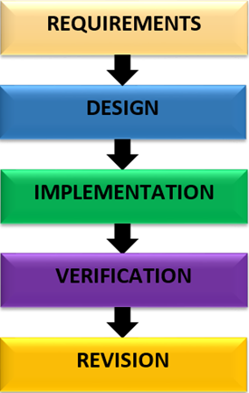 The researchers used the implemented the Water Fall Model. This includes requirements, design, implementation, verification, maintenance, and revision phases

Figure 1. Development Paradigm of the Barangay Management Information System of the Municipality of Mayantoc.

Figure 1 depicts the systems development process involved in developing a Barangay Management Information System for the Municipality of Mayantoc.

**Requirements Phase**. In this phase, the researchers study how the barangay staff properly and carefully gather information of each residents, how to record each data and how to safely store it, how the resident request is being process, how to issue the request, and the researchers gather all the possible documents that the barangay offered.

**Designing Phase**. During this phase, the data gathered will be designed, including the Entity Relationship Diagram, Flowchart Diagram, and specially the interface of super admin, admin and the resident.

**Implementation Phase**. In this phase, the researchers will begin the development of the information system. The researchers will implement the design done during the designing phase. In creating the interface the researcher used HTML, CSS, and JavaScript and to make the system’s function they used PHP. While the database used to store all data is MySQL.

**Verification Phase**. In this phase, the system will be evaluated by both resident and barangay secretary from the barangay, to test the functionality, interface, usability, and security of the system, to also check and look for bugs and errors that need to be fixed.

**Revision Phase**. In this phase, the researchers will revise all errors and fix all the bugs in the system, consider the comments and suggestion of the users, and make the improvement needed under the verification phase.

## Data Gathering Procedures

The researchers conducted an interview to gather all necessary data that will serves as guide in developing the System. The researchers prepared a questionnaire checklist for the respondents which is validated by the capstone adviser and distributed on selected residents and barangay personnel who participated the survey. The researchers explained to the respondents about the significance of their responses to the study. The researchers requested to the respondents to answer the questionnaire sincerely. The researchers simplifies some terms to the respondents in the survey questionnaire in order to answer freely with complete knowledge of their obligations as the respondents of the study. The researchers used a mobile device and laptop to test the system. The researchers demonstrate the features of the system usability and functionality, thorough residents have knowledge on how the system works.\

## System Design

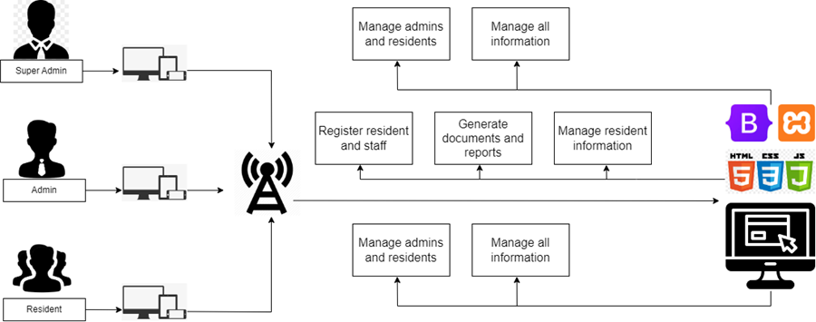In Figure 2, the Barangay Management System has only three types of users, the administrator for the super admin which covered all the barangays, the administrator for the barangay admin and the resident which is verify as the clients. As seen in Figure 2, the system was developed using HTML, CSS, PHP, and JavaScript. The database of the system was designed using MySQL. This was used to store all the information in the system.

Figure 2. Architectural Design of the Barangay Information System of the Municipality of Mayantoc.

The super admin verifies and manages all information of both residents and admins, while the admin registers the residents and store staff information, and manages the information added in the system. The admin can also generate the requested documents and verify incident report of each resident. Then each resident can request any documents related to barangay services and able to report incident like blotters

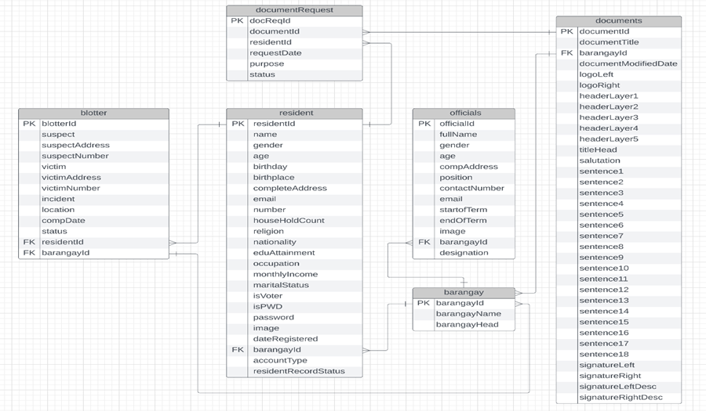 As seen in Figure 3, the Barangay Management Information System consist of six (6) tables, each table has a primary key and foreign key which is connected in every table.

Figure 3. Entity Relationship Diagram of the Barangay Management Information System of the Municipality of Mayantoc.

The blotter and resident table are linked by the key column residentId. It is a foreign key in the blotter table linking to the primary key residentId in the resident table. Therefore, only one record of the resident table can point to multiple records in the blotter table, because residents can perform reports of blotter several times which is a one-to-many relationship. The blotter table and barangay table are linked by the key column barangayId, which is a foreign key in the blotter table and a primary key in the barangay table. Since, residents can file blotters in other barangay which correspond to the location of the suspect. That means it is a one-to-many relationship.

Resident table and Document Requests are linked together by the key column residentId which is a primary key in both tables. Hence, residents can request different documents using the system. This makes a one-to-many relationship. At the same time, the table DocumentRequests is linked by the key column DocumentId which is a primary key to the DocumentRequest table and also a primary key to the documentId in Documents table. Thus, upon acquiring documents, residents must send a request to the admin which includes their personal information and purpose, that may serve as a validation on generating documents. So, this makes a one-to-many relationship. Similarly, the documents table and barangay table are linked via a one-to-many relationship. Since each barangay can request different documents, the admin can add a new document form, which is formatted according to the composition of each barangay document. As well as the barangay and residents table are connected via one-to-many relationship, and linked by the key column barangayId which is a primary key in the barangay table and a foreign key in the resident table. Thus, the barangay holds the resident's information and residents are covered by the barangay. While officials’ tables are connected to the barangay table via one-to-many relationship, since each barangay has its own list of their barangay officials to the system.

### Tools used in the Development

The following hardware and software were used to develop the Barangay Information Management System of the Municipality of Mayantoc.

**Hardware.** This part presents the devises and equipment and other hardware used during the development and implementation. Indicate the minimum and recommended specification for the development. This should be in Table form indicating the specification of actual devise.

Table 2. Table Title Should be end With a Period.

|  |  |
| --- | --- |
| **first** | **level heading** |
| 4.50 – 5.00 | Maintain 2 single spaces (12 pts) |
| 3.50 – 4.49 | Before |
| 2.50 – 3.49 | And |
| 1.50 – 2.49 | After |
| 0.00 – 1.49 | The Table |

**Software.** This part should indicate the software used in the development of the IT Solution. Include software used for the front end and the back end.

* **Data Mining Tools or Data Preprocessing Tools**
* **Programming Language.** Describe in a not too long sentence.
* **Scripting Language.** Describe in a not too long sentence.
* **DBMS.** Describe in a sentence.

## Evaluation /* If User Evaluation and/or Subject Expert Evaluation */

**Scale to be Used in the Evaluation.** Discuss here what was the scale used in the evaluation and the way of interpreting the result of the evaluation (see Likert Scale and Weighted Mean).

Table 3. Table Title Should be end With a Period.

|  |  |
| --- | --- |
| **first** | **level heading** |
| 4.50 – 5.00 | Excellent |
| 3.50 – 4.49 | Very Satisfactory |
| 2.50 – 3.49 | Satisfactory |
| 1.50 – 2.49 | Satisfactory |
| 0.00 – 1.49 | Poor |

Also, don’t cut tables included in your text. Tables should be placed along with the text or in the Appendix. If it is included in the text, it should be presented after it has been mentioned.

**Respondents to the Evaluation.** Discuss here WHO WERE the evaluators and how they were identified. Indicate here also the research locale. Include how was the number of participants identified (sample size) saying what was the formula used (i.e. see Slovin’s Formula for the stratified systematic sampling) and how they were identified (i.e. sampling technique) say for example – random sampling or systematic sampling.

## Validation Testing /*If Model Testing/Software Testing as Method Evaluation */

### Data

Describe here the data that was used in the evaluation. What were the ways that data was prepared (e.g. data cleaning, feature selection, etc.) What and how was it composed, where it was derived from or its source.

Table 4. Data Dictionary (if needed i.e. tabular dataset)

|  |  |  |  |  |
| --- | --- | --- | --- | --- |
| **Atttribute Name** | **Input MASK** | **Data Type** | **Sample INPUT** | **Description** |
|  |  |  |  |  |
|  |  |  |  |  |
|  |  |  |  |  |
|  |  |  |  |  |
|  |  |  |  |  |

### Accuracy /* Add additional <Heading 3> for

This part should discuss how you determined or tested the accuracy if it is what was mentioned in the objectives. This may include algorithm, a formula as may be adoptable or applicable based on model study or related literature. Insert the formula using Insert menu, and Equation function. The formula should be inserted in the middle of the table below by clicking the “Type equation here.” and the Equation Dialog Box or panel will automatically appear. Equation should be numbered as follows:

|  |  |  |
| --- | --- | --- |
|  |  | (1) |

You may say that accuract was calculated using (1) If to insert another formula, just click Insert Menu then choose Autotext /* that beside the Text Box function */ then InsEq tool. The sequence of formula is auto generated like as follows.

|  |  |  |
| --- | --- | --- |
|  |  | (2) |

# RESULTS AND DISCUSSION

## Name of the IT Solution

The IT Solution is the section which details the technology that was developed (i.e. features, design implementations).

### User Requirements

This part should explain what the system will do from the user’s perspective or view. It should discuss the features per module of the system.

This section presents the logical design of the IT Solution as a result of the requirement specification phase or activity. It presents the data intake of system, how it is processed or transformed and what is the output.

The logical design can either be either of the following. This can also be the conceptual framework of the IT Solution or the study.

Input Process Output (presented per permission or perspective of user – User, Administrator, etc)

Flowchart

### Hardware and Software Requirements

This should indicate what is the minimum requirements of the devise in which the IT Solution or technology can run or operate on. Also include the associated software needed.

## Evaluation /* or Validation */ Results

Evaluation or Validation Results presents the result of the user evaluation or any testing process used with software tools to validated the IT Solution based on the metrics in the specific objectives.

Introduce the table first. Refer to it as labeled. The format of this section may be as the following example. Table 4 presents the result of evaluation for the Software Usability.

Table 5. Evaluation of Users on Software Usability.

|  |  |  |
| --- | --- | --- |
| **1. USABILITY** | **Average** | **Descriptive rating** |
| 1.1 Statement from the Questionnaire | 5.00 | Based on scale |
| 1.2 Add rows if necessary | 5.00 | Very Satisfactory |
| 1.3 Add rows if necessary | 4.89 | Very Satisfactory |
| **Section Mean** | **4.96** | **Very Satisfactory** |

Discuss the content of the table say Table 4 here but IT SHOULD NOT BE A REPETITION OF WHAT CAN BE SEEN IN THE TABLE. Remember not to repeat in paragraph what the Tables already indicate. What do the numbers tell the reader. Find what is the trend, interpret and do result analysis.

Be consistent in the number of decimal places and units in your resulting tables. Table 5 may be another way to express a result especially those who conducted software or model testing. Design a table depending on what is being determined and trying to show for analysis.

Table 6. Accuracy of the IT Solution.

|  |  |
| --- | --- |
| **dataset** | **score** |
| Training Dataset (60%) |  |
| Model Test Dataset (40%) |  |
|  |  |

Insert screenshots of tools or parts of the system that shows what were evaluated on the parameters measured (example Security = Log-In Interface). Introduce figures first and reference them using their caption. For Model Testing, a graph or chart can be inserted for interpretation.

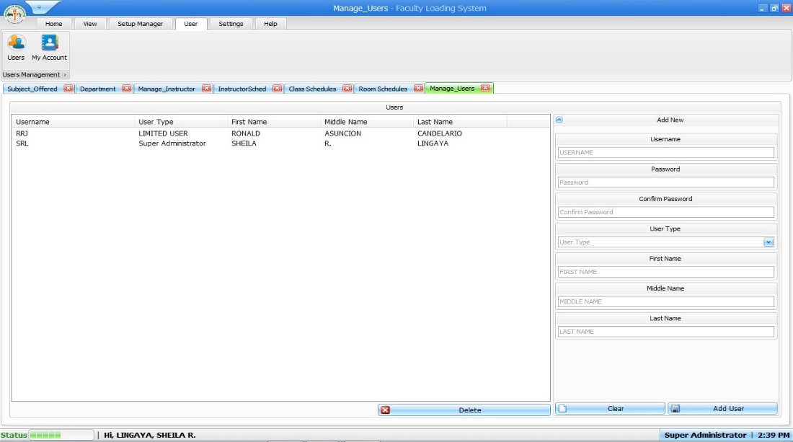

Figure 4. Screenshot Showing Evaluated Feature

For example, Figure 2 shows the Add User Interface where the user adds data to complete the transaction in adding of user for Administrator and Super Administrator. Administrator Account and Super Administrator account has the same privilege in using the system while the limited user can only add schedule.

# SUMMARY, CONCLUSION AND RECOMMENDATION

## Summary

This summarizes the research or the study. In paragraph form. This should state what was learned and not a repetition of the results. This can be based in the methodology. Include objective of the research, the principal results.

## Conclusion

1. The general objective is addressed in the conclusion.
2. This should be numbered and in one-to-one correspondence with specific objective.

## Recommendation

The researchers can exhaust all means and may recommend the following:

1. Using other technology, hardware or programming language.
2. Using another related or applicable application development environment.
3. Use of other datasets or testing or validation technique.
4. Application in another locale, transaction or application.
5. Including what has been missed out in scope.
6. Comparing with other similar technology.

# REFERENCES

Use APA 7th Citation Style formatting for all references (in the body and in the listing here). Insert using Mendeley.

APPENDICES

##### <Appendix A:> <Title>

Place your appendices here. Please be sure that these have been referenced in the body of document.

Appendices should include the following in separate pages:

User Interfaces

Sample Outputs or Reports Generated

Questionnaire

Evaluators (especially Subject Experts’) Profile

Grammarian’s Certificate

TAU DRD ISO FORMS ACCOMPLISHED